Glottal filter order = 2, file: Nick00

VT filter order = 20

/i/ in ‘green

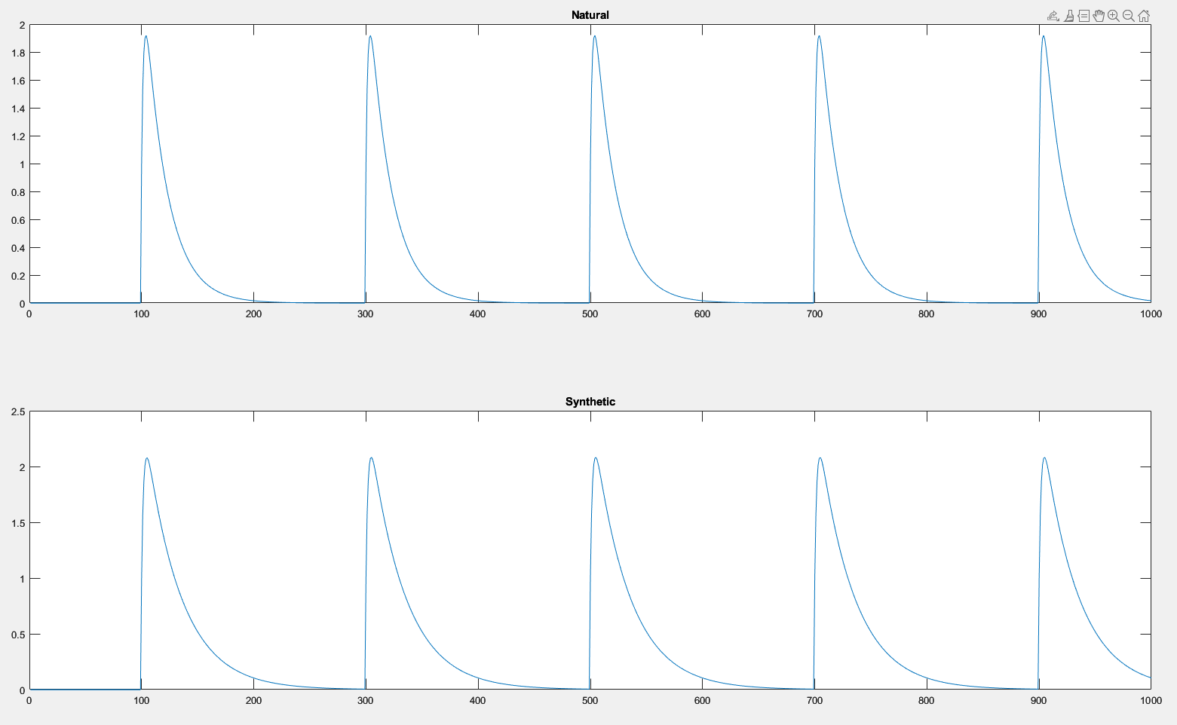

/ai/ in ‘light’

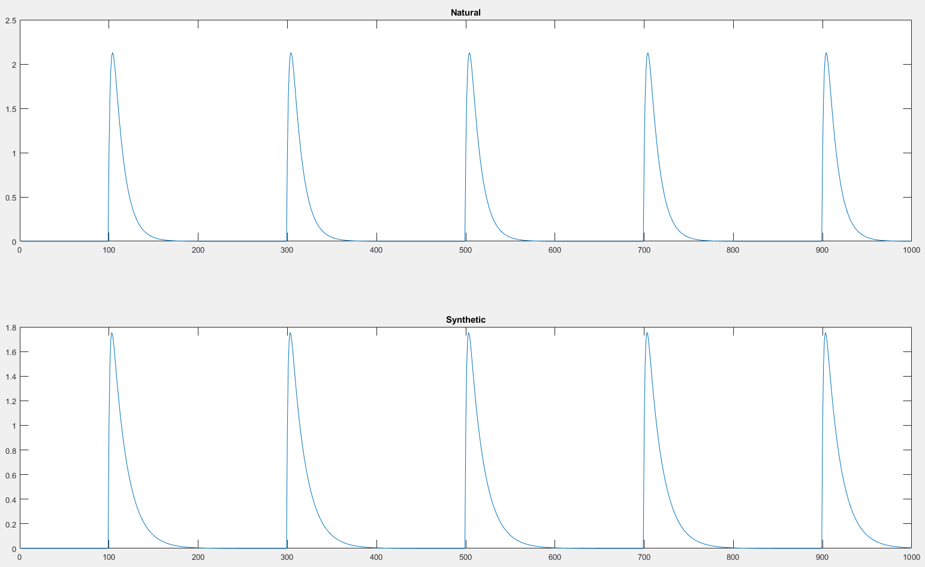

/aƱ/ in ‘brown’

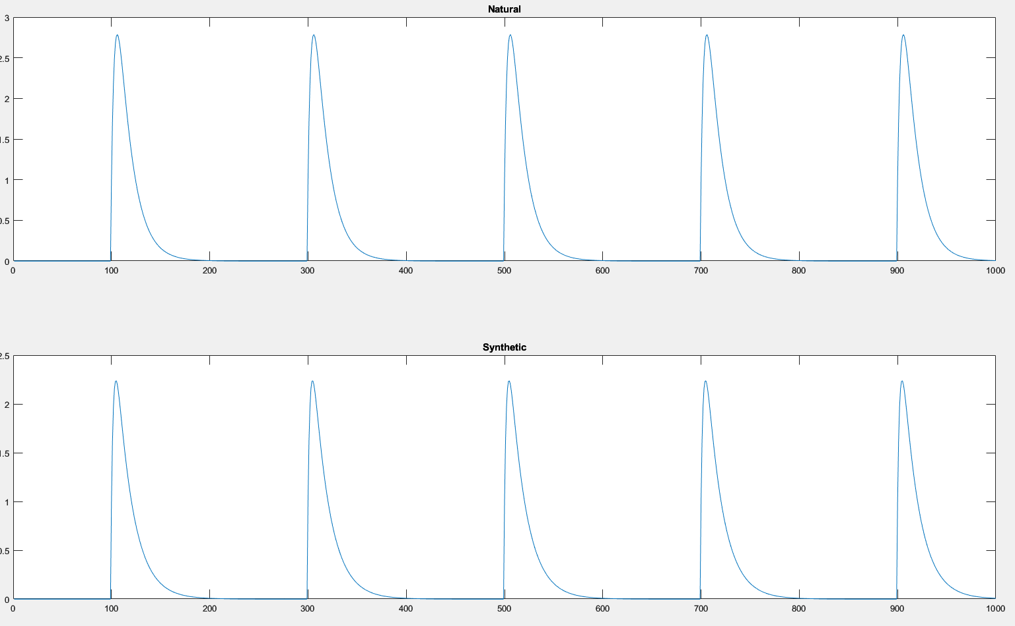

Synthetic GVV looks slightly wider. Both waveforms look similar in both cases.

Glottal filter order = 16,

VT filter order = 20

/i/ in ‘green

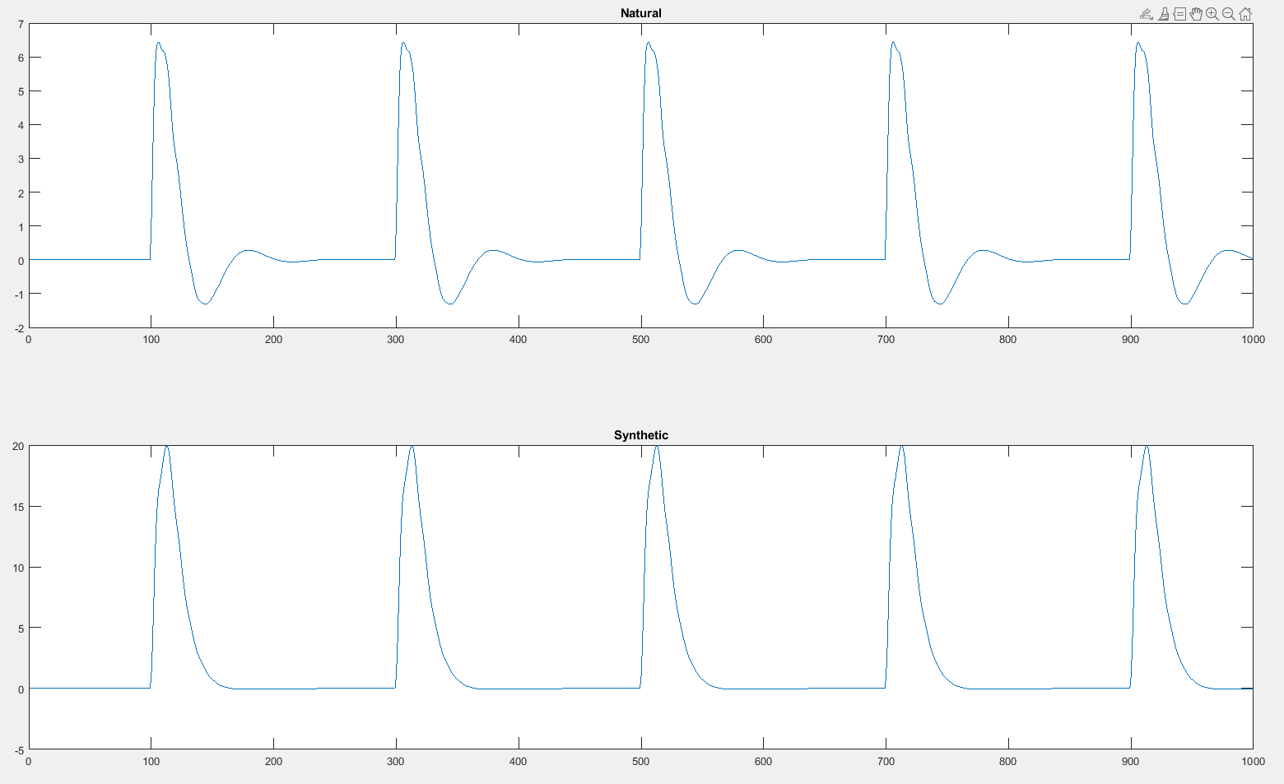

/ai/ in light

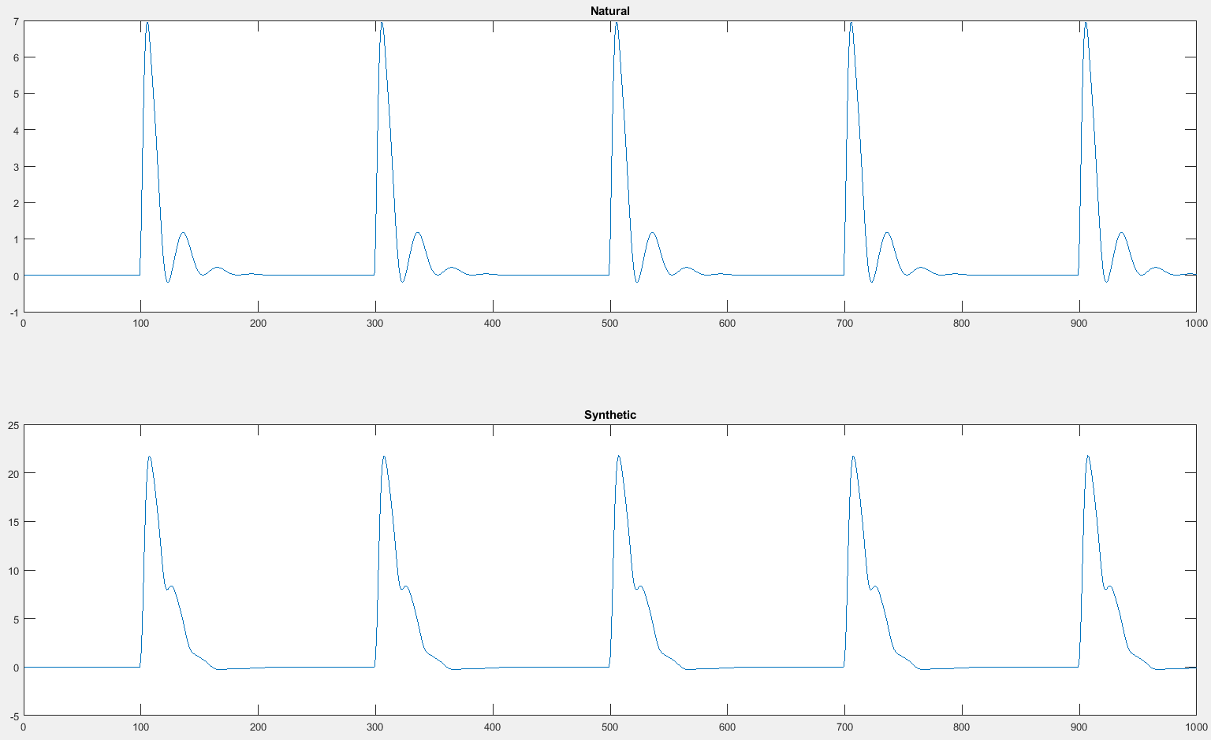

/aƱ/ in ‘brown’

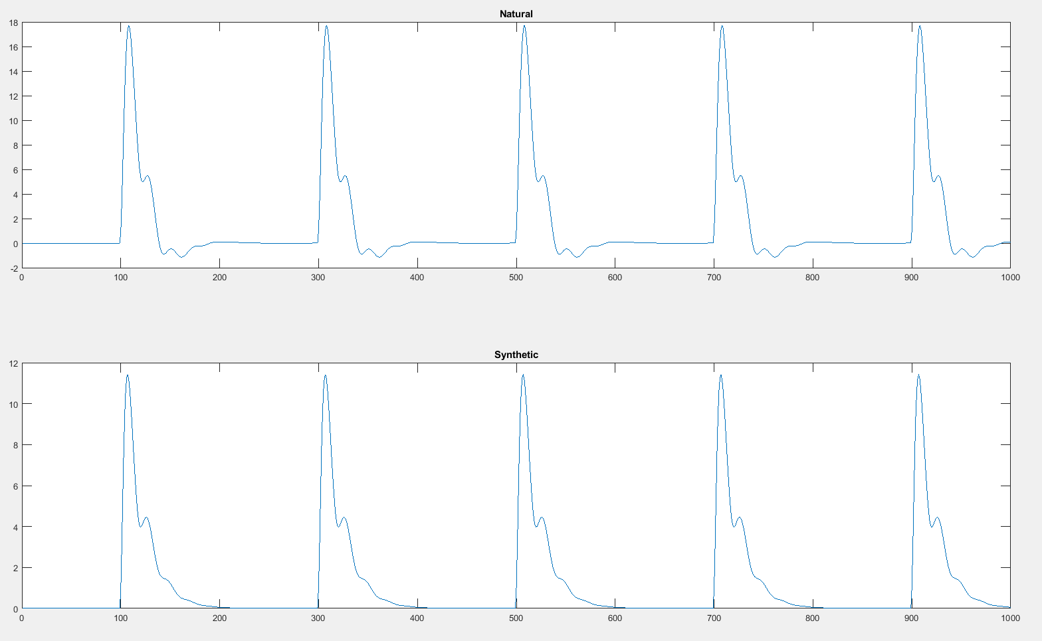

Box

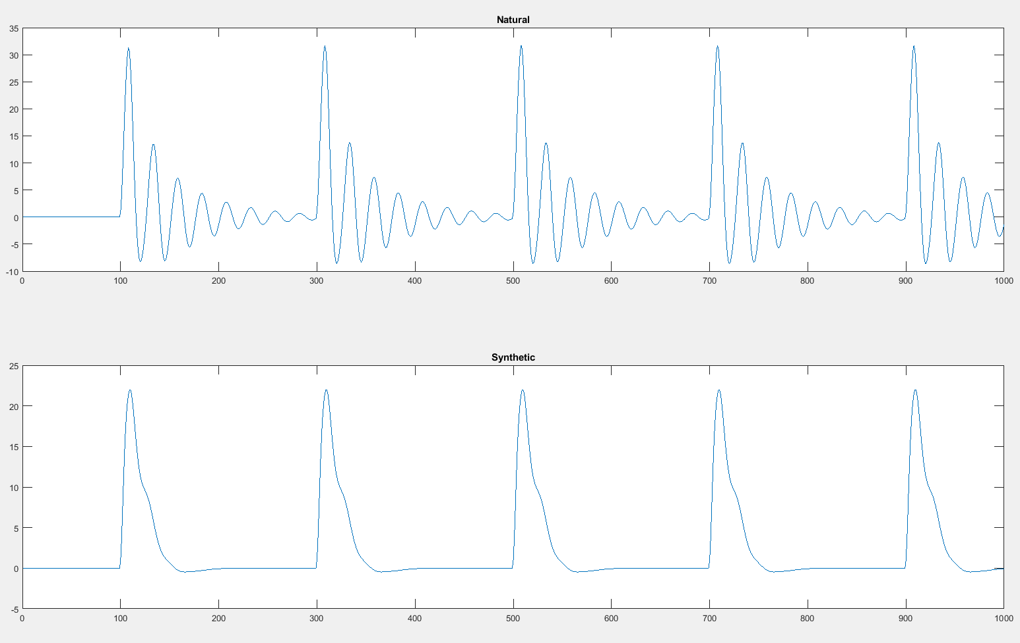

/I/ in Flickered

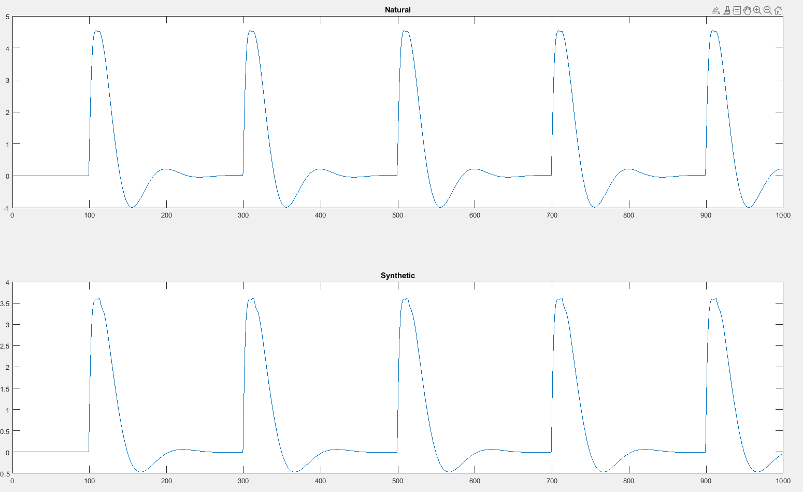

/i/ in ‘leave’ file: Nick02

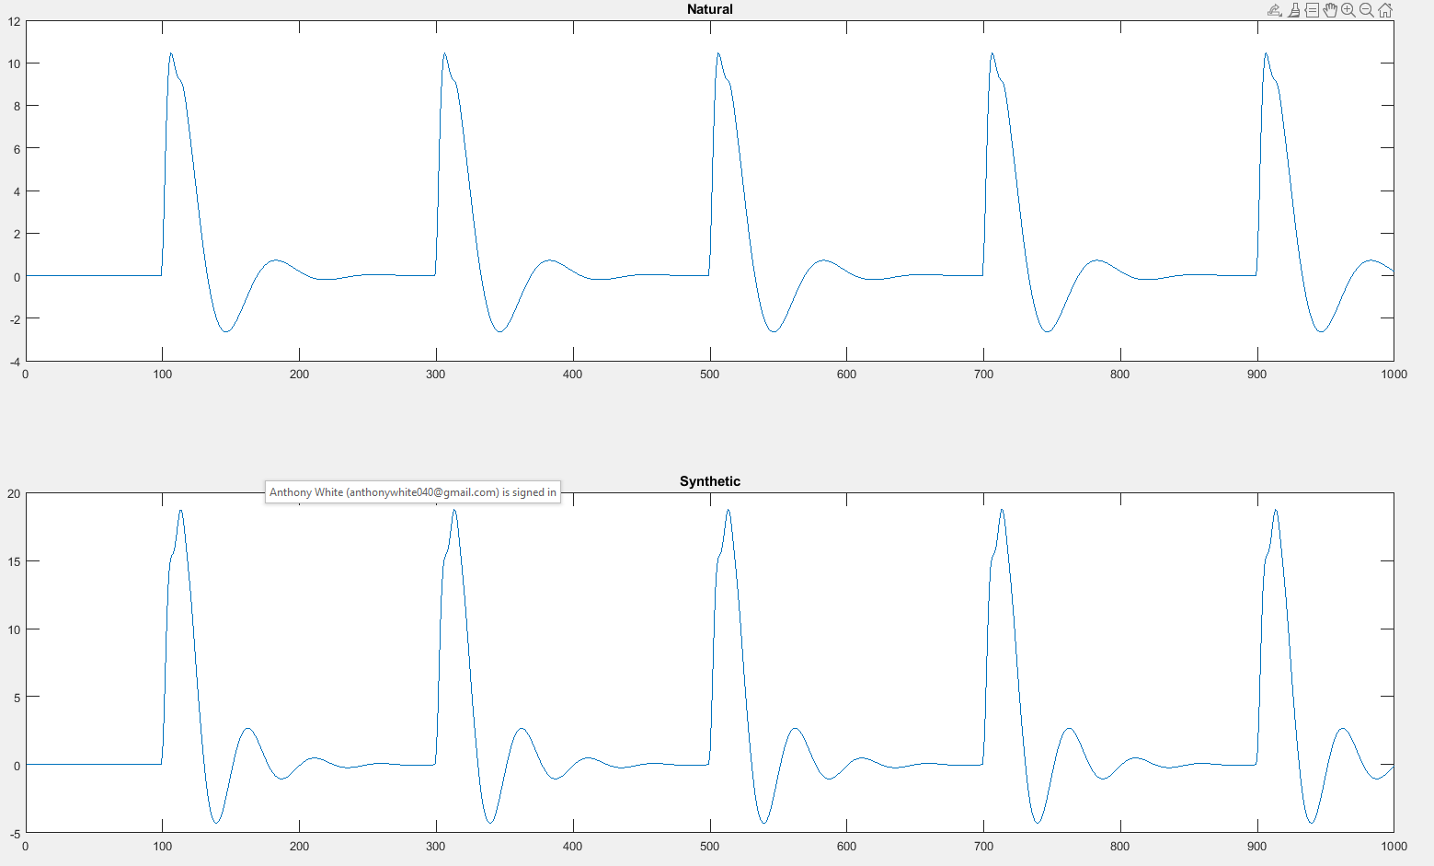

/a/ in ‘carpet’

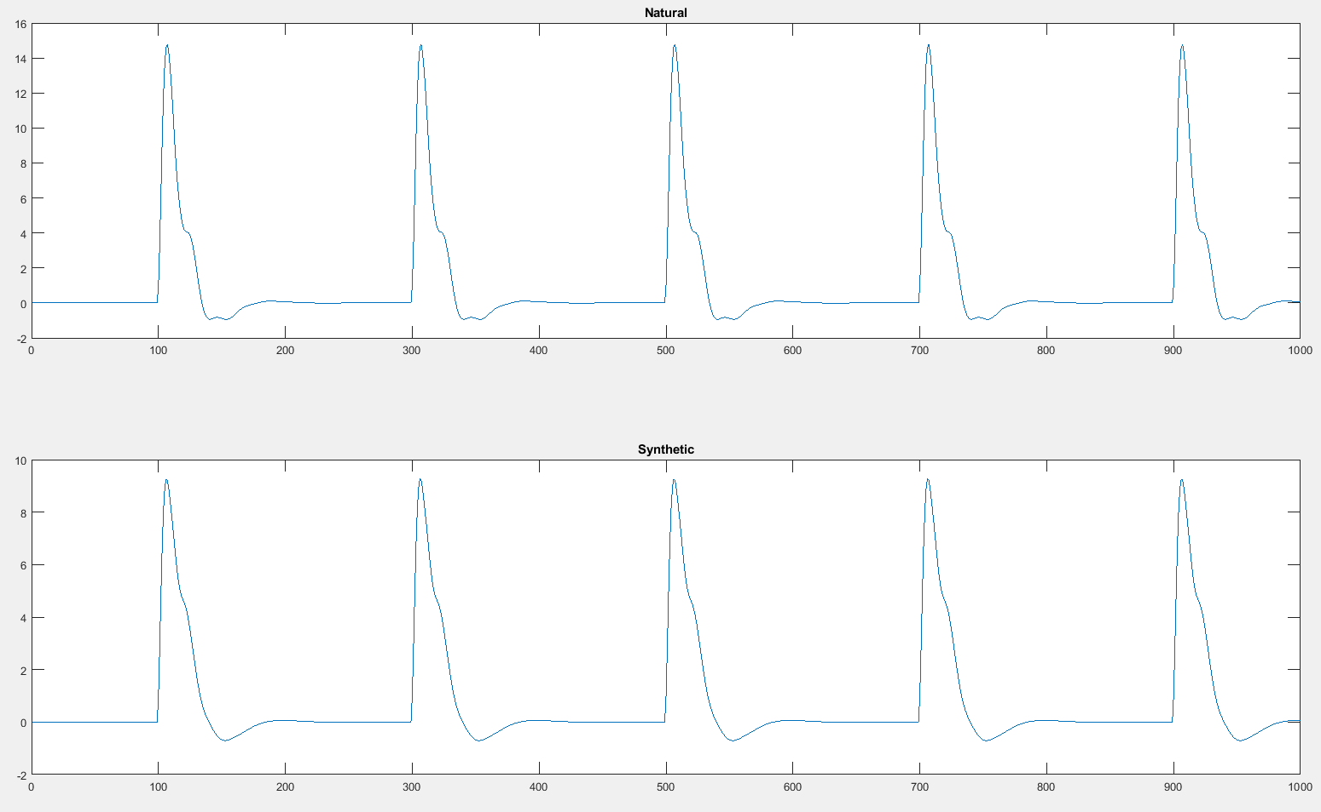

/ai/ in ‘right’

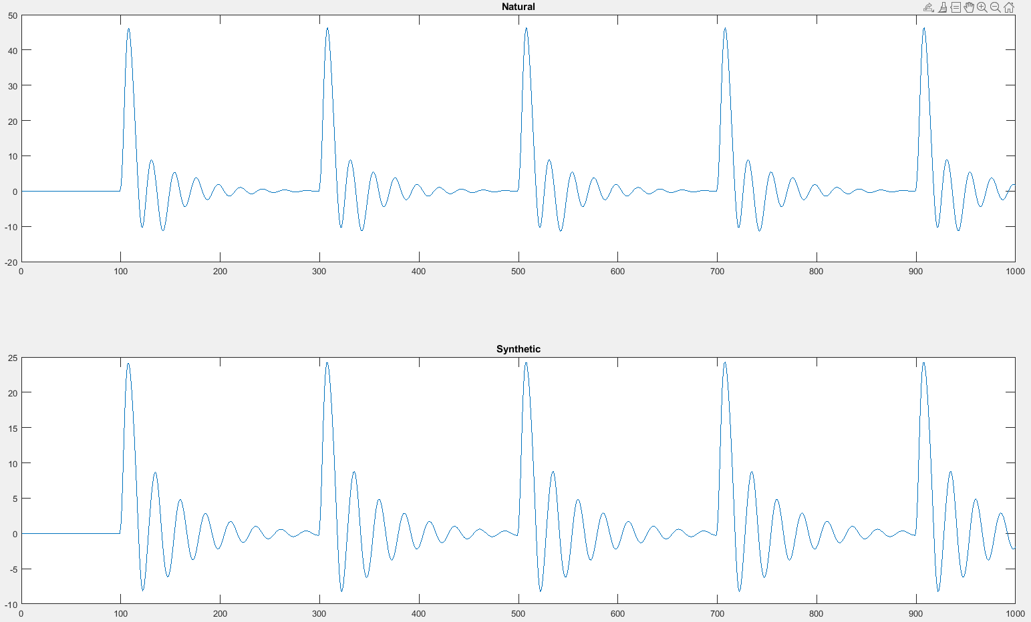

/æ/ in ‘hand’

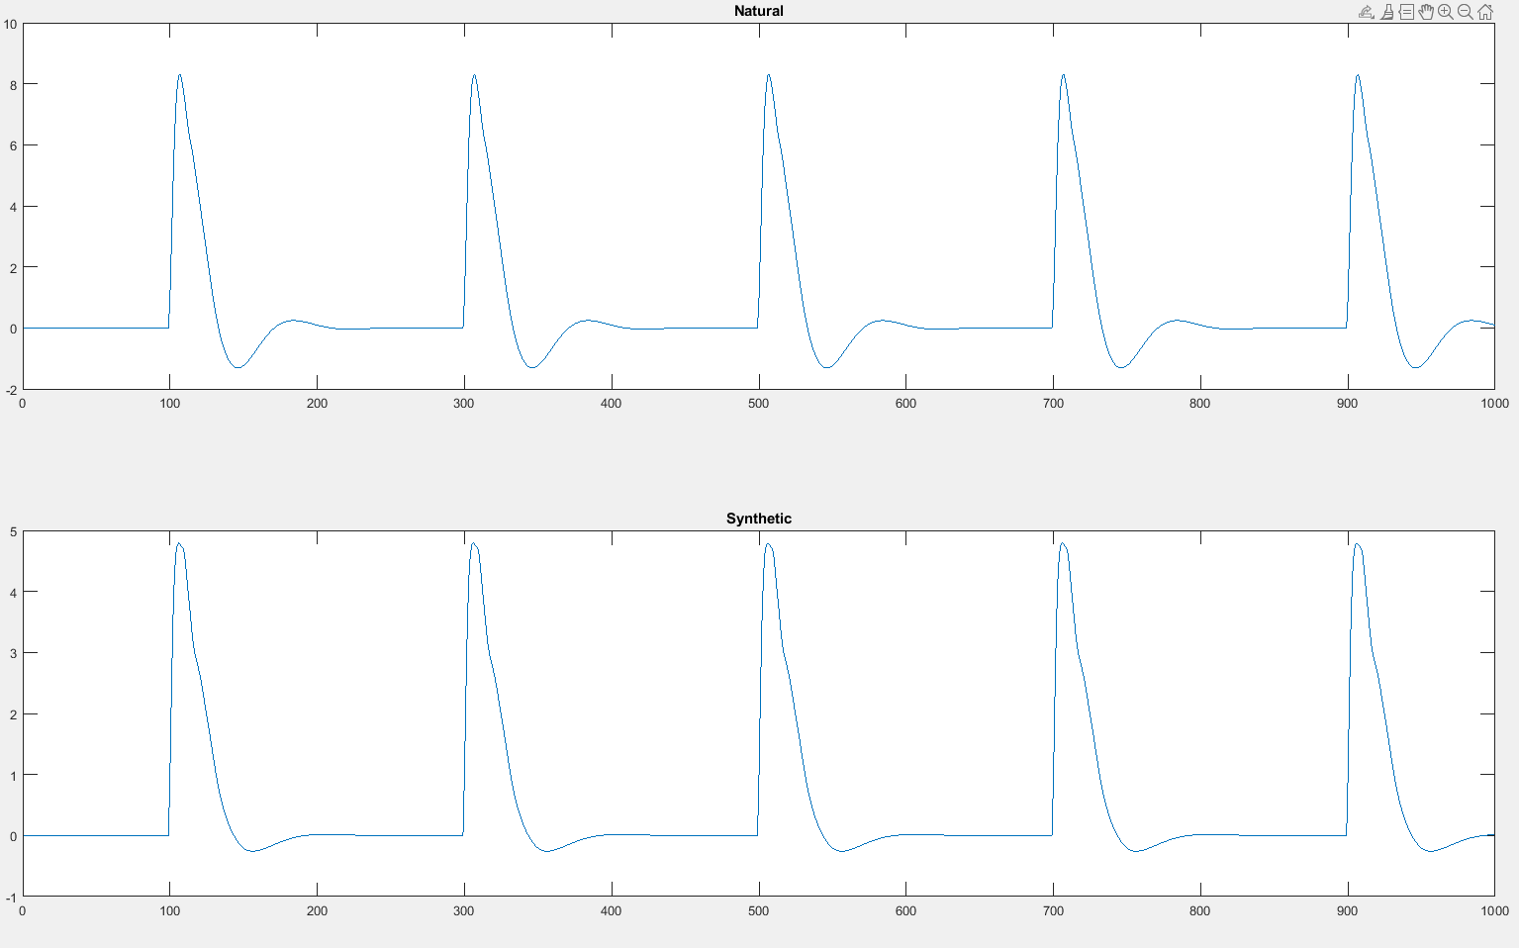

/ai/ in ‘side’

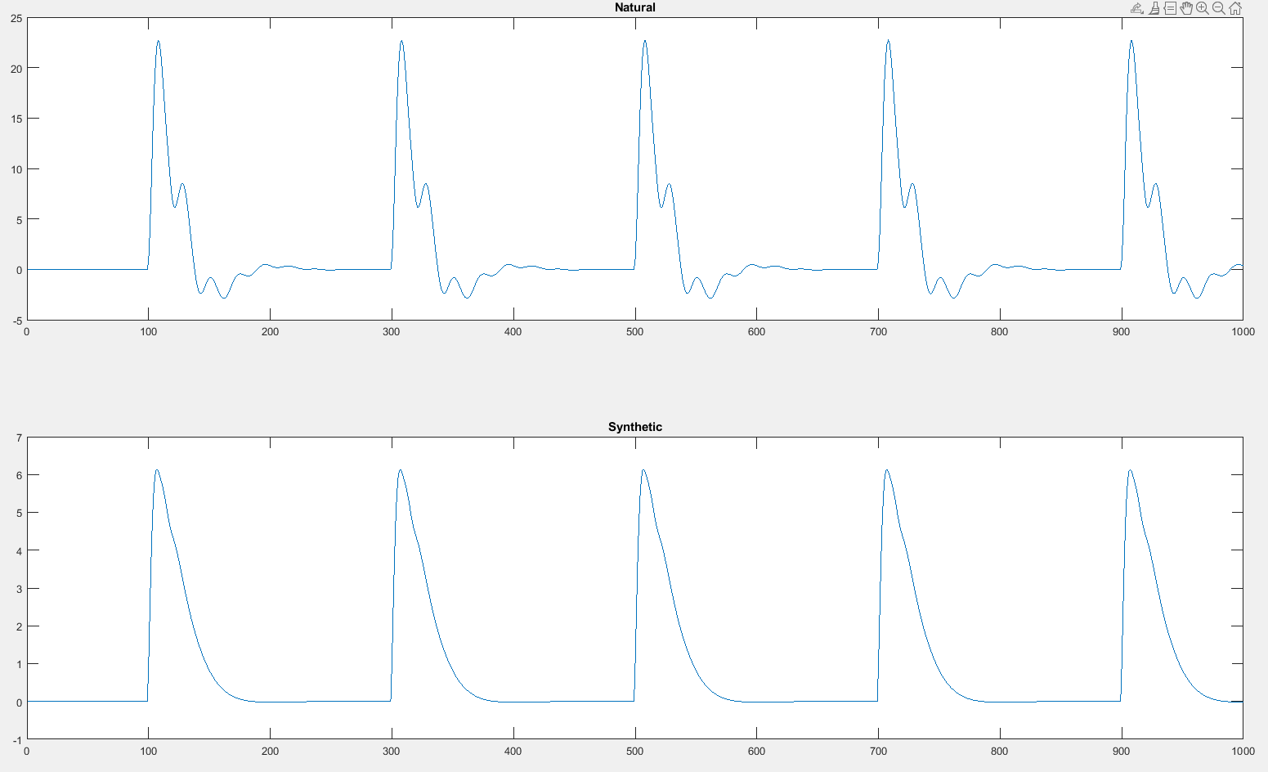

/i/ in ‘please’ file: Nick03

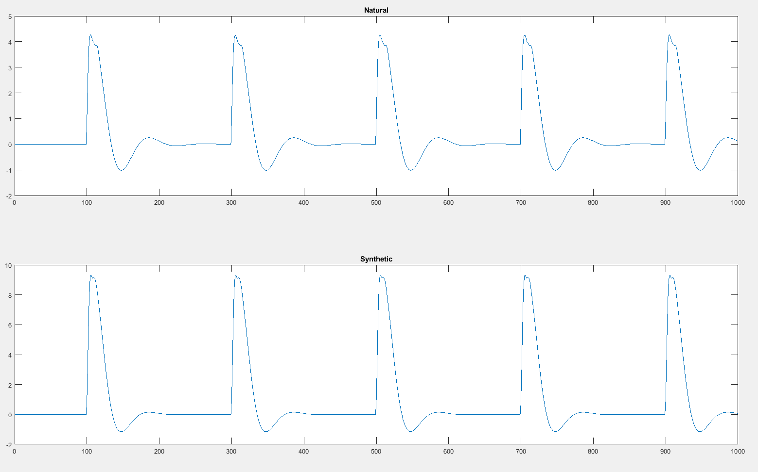

/a/ in ‘answer’

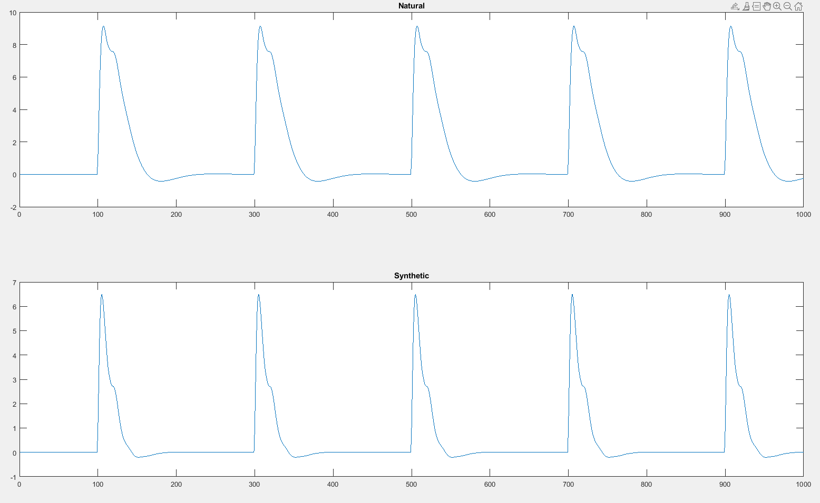

/æ/ in ‘that’

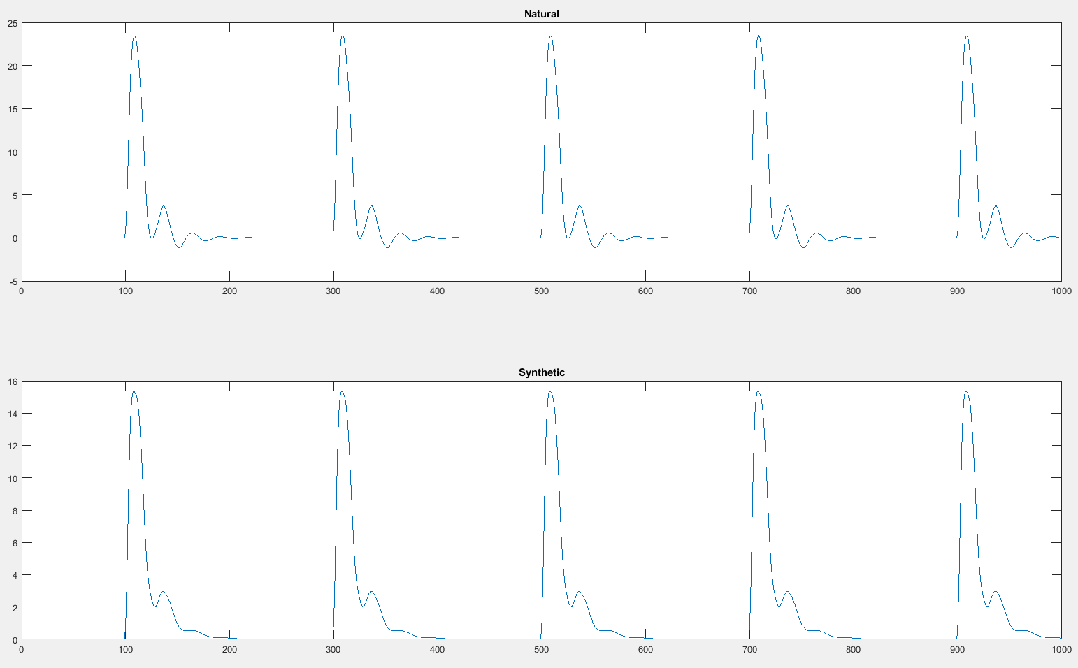

In ‘phone’

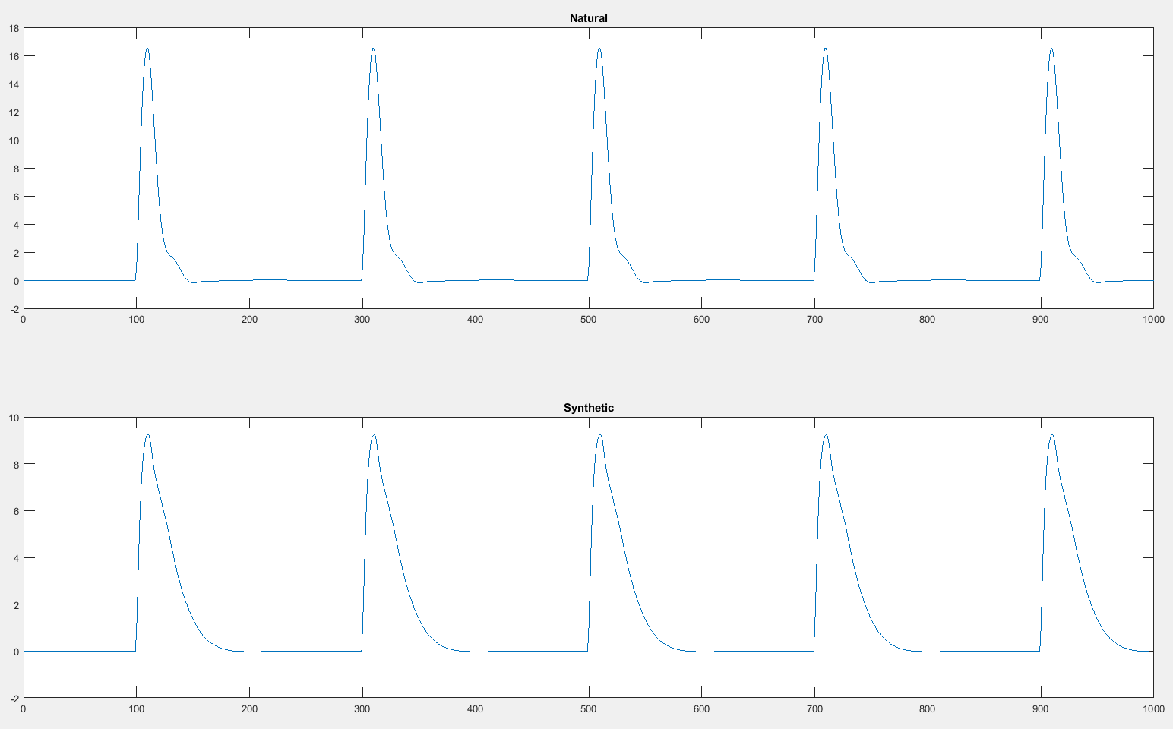

Glottal filter order = 2, file: Isabella00

VT filter order = 20

/?/ in ‘wrote’

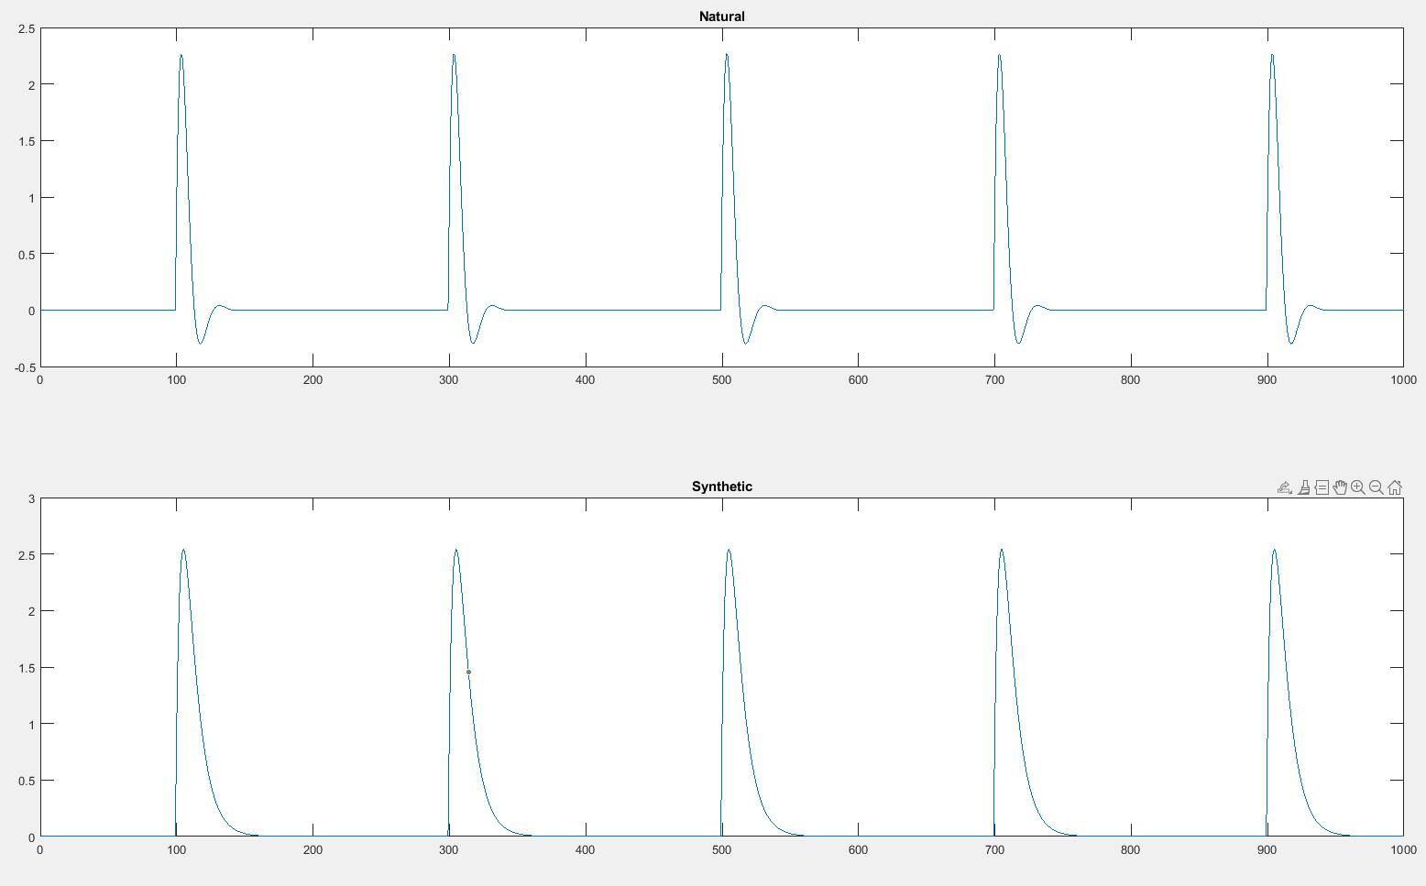

/aƱ/ in ‘down’

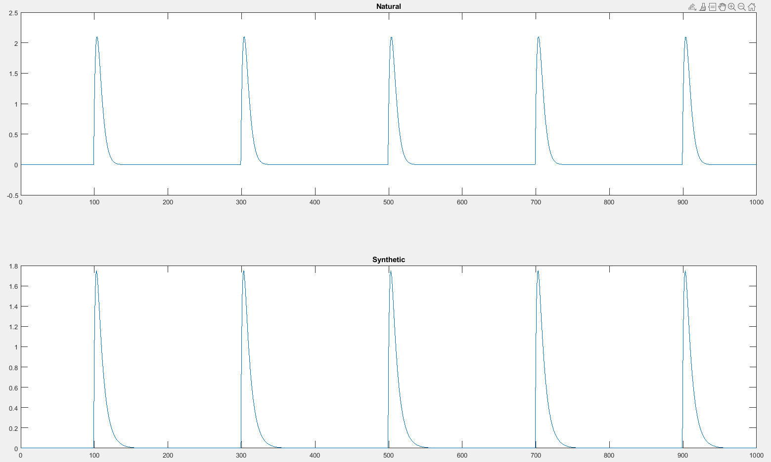

/ɒ/ in ‘long’ 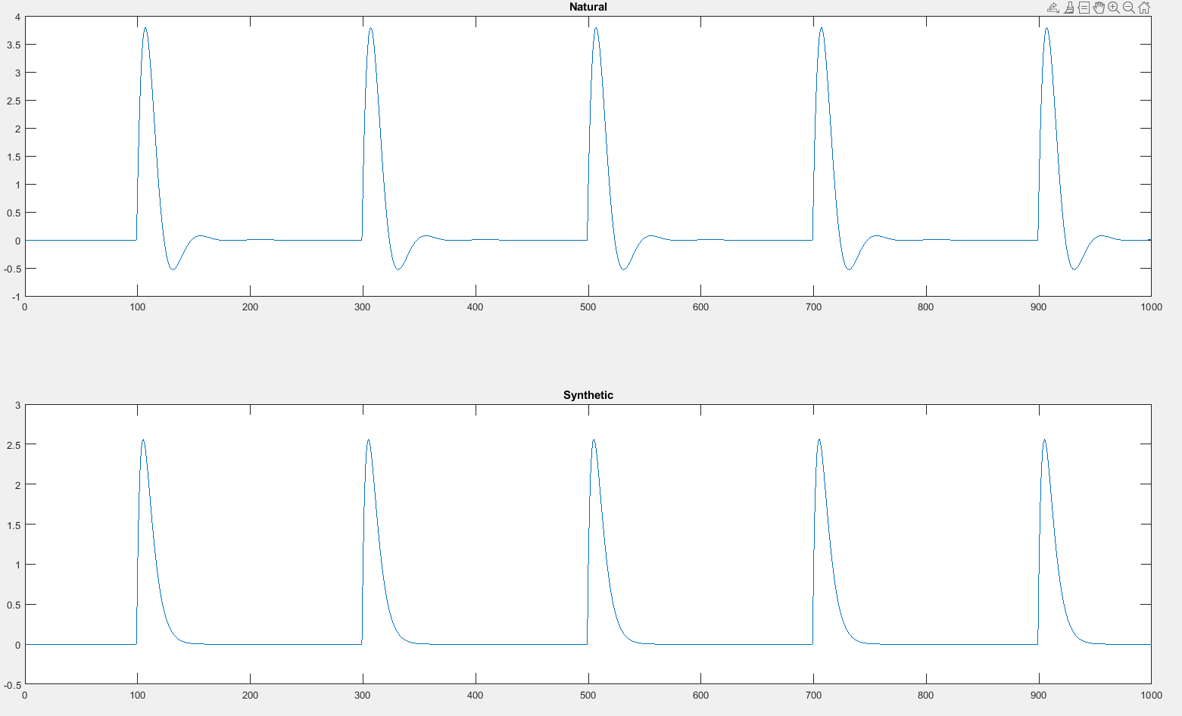

/I/ in ‘list’

